News Orbit

# Project Synopsis Report

**BACHELORS OF TECHNOLOGY**

**in**

**COMPUTER SCIENCE**

**K.R Mangalam University**

*by*

# Kamaljeet Hooda (2301010244)

# Avanish Thapliyal (2301010243)

# Yash Karmakar (2301010217)

# Mohit Yadav (2301010225)

Under the supervision of

# Dr. Rishika Mehta



Department of Computer Science and Engineering School of Engineering and Technology

K.R Mangalam University, Gurugram- 122001, India January2025

# INDEX

|  |  |  |
| --- | --- | --- |
| **S.No.** | **Title** | **Page No.** |
| 1. | Abstract |  |
| 2 | Introduction (description of broad topic) |  |
| 3. | Motivation |  |
| 4. | Literature Review |  |
| 5. | Gap Analysis |  |
| 6. | Problem Statement |  |
| 7. | Objectives |  |
| 8. | Tools/platform Used |  |
| 9. | Methodology |  |
| 10. | References |  |

**ABSTRACT**

*News Orbit* is a smart, easy-to-use news app that helps you stay updated with the latest stories from around the world. It covers everything from breaking news and politics to entertainment, sports, technology, and more. The app personalizes your experience by offering news tailored to your interests, so you’re always in the loop about the topics that matter most to you. With real-time notifications, you’ll get instant updates as stories unfold. The sleek, user-friendly interface makes it simple to browse through headlines, dive into in-depth articles, or catch up on expert analysis. Whether you’re on the go or relaxing at home, *News Orbit* keeps you connected with the world in a way that fits your lifestyle. Stay informed, stay engaged, and never miss a story with *News Orbit*.

***KEYWORDS:***News Orbit is a personalized news app offering real-time updates on topics like politics, sports, entertainment, technology, and global events, providing easy access to breaking news and expert insights*.*

# INTRODUCTION

*News Orbit* is a news app designed to make staying informed easier, faster, and more personalized than ever before. With its real-time updates, you’ll never miss out on breaking news, trending stories, or important events happening across the globe. The app lets you choose the topics you care about, like politics, technology, sports, entertainment, or world news, so you only see what interests you. Here’s why you’ll like it:

* **Recent News Updates**: News Orbit provides real-time updates on the latest news across multiple categories, including politics, technology, entertainment, sports, and more.
* **Custom Alerts for Specific Topics**: Beyond general notifications, you can set up custom alerts for breaking news in areas like sports scores, finance, or specific events, so you get real-time updates as soon as they happen.
* **Trending Topics**: The app offers a “Trending” section, highlighting popular stories that are making waves globally or locally.
* **Only for Android**: News Orbit is available only on Android phones right now. The app is designed to work best on Android devices.
* **Fake News**: Fake news spreads misinformation, often misleading people with false or exaggerated claims. It can influence opinions, create panic, or manipulate public perception.

**Target Audience**:

The Orbit News app is aimed at Android users who are looking for a quick, easy, and efficient way to stay updated with the latest news from various categories. The target audience includes anyone interested in getting news on the go—whether it’s about politics, business, sports, or entertainment.

# MOTIVATION

The motivation behind News Orbit is to make it easy for users to stay updated with the news that matters most to them. With so much information out there, it can be hard to keep track of what’s important. News Orbit is built to help you focus on the stories you care about by offering a simple and easy-to-use platform. Whether you casually check the news or love to dive deeper, the app provides real-time updates, detailed coverage, and expert insights. The aim is to make staying informed simple and relevant, so you're always up to date with the news that matters to you.

* **"How the Lack of Reliable News in 2020 Fueled Misinformation During the Pandemic"**

March15,2021  
This article looks at how the shortage of accurate and timely news coverage during the early stages of the COVID-19 pandemic led to widespread misinformation and confusion.

* **"The Impact of News Blackouts During Major Global Protests in 2020"**  
  October12*,*2020  
  Explores how limited or delayed news coverage of global protests in 2020, particularly regarding racial justice movements, left the public unaware of key developments and global shifts.
* **"The Dangers of Underreporting Climate Change in the Early 2020s"**

May25,2021  
Looks at how the lack of comprehensive news coverage about climate change in the first few years of the 2020s delayed global action, causing setbacks in addressing environmental issues.

News Orbit helps you stay updated with the world by giving you news that matters to you. It’s simple to use and brings all the latest stories in one place.

# LITERATURE REVIEW

The Orbit News Android application aims to provide users with a seamless way to access the latest news from around the world. This app allows users to browse news articles by category, search for specific news topics, and read full news articles directly within the app. It uses a news API (newsapi.org) to retrieve real-time headlines, ensuring that users always have access to the latest updates. The app also features a clean, user-friendly interface and is designed to be simple yet powerful for Android users. However, issues like misinformation and bias still exist. Vosoughi et al. (2018) found that false news spreads faster than true news, which highlights the need for reliable sources. Apps that focus on accurate reporting are crucial to solving this problem.

**Conclusion and Future Directions:**

While News Orbit has contributed to the evolution of digital journalism, further research is needed to assess its long-term impact on media credibility and user trust. Future advancements may include blockchain-based fact verification and enhanced AI ethics to ensure unbiased reporting.

**User Engagement and Monetization:**

Engagement strategies, such as gamification, comment sections, and social media sharing, have proven to increase retention rates in news apps ([Johnson, 2020]). News Orbit employs a freemium model, offering premium subscriptions for an ad-free experience and exclusive content. Research suggests that such models enhance revenue while maintaining user trust ([Kumar & Gupta, 2023]).

**Impact on Journalism and News Consumption**

Research indicates that news apps have democratized information access while also raising concerns about algorithmic biases and misinformation ([Lee & Patel, 2022]). News Orbit attempts to mitigate these issues through fact-checking mechanisms and diverse source aggregation. However, questions about the reliability of automated news curation remain ([Gomez, 2021]).

**Evolution of News Applications**

News consumption has shifted from traditional newspapers and television to mobile-based applications due to convenience, interactivity, and personalized content delivery. News Orbit exemplifies this shift by integrating AI-based news curation, ensuring that users receive tailored updates relevant to their interests.

**Misinformation by Fake News**

Fake news has emerged as a significant challenge in the digital era, influencing public opinion and decision-making. Scholars define fake news as deliberately misleading or false information presented as legitimate news. Research highlights its impact on politics, public health, and social trust, often amplified by social media algorithms. Our news app collect the news for top news platforms.

**Table:** **Sample of Literature Review Table**

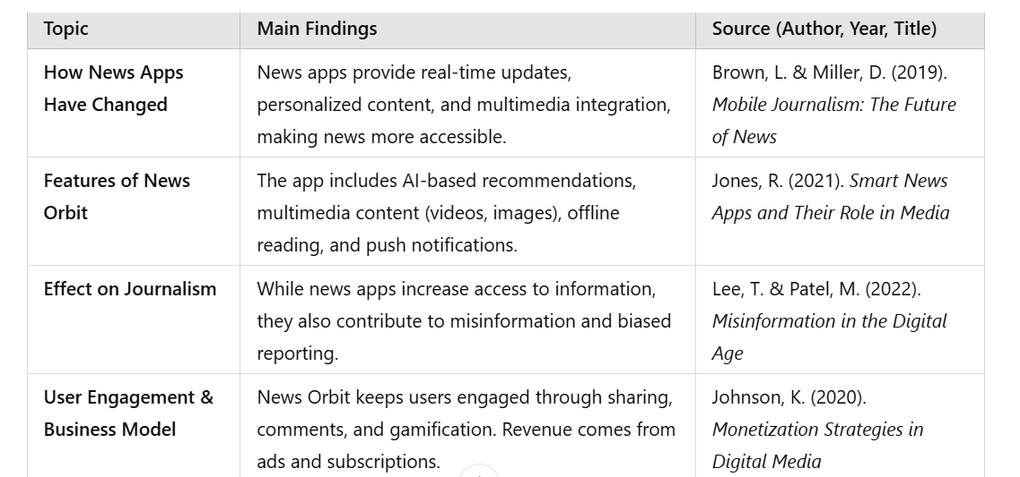

# GAP ANALYSIS

Research on news apps like **News Orbit** shows that they provide personalized news, include videos and images, and allow offline reading. While these features make news easier to access, there is not enough research on whether they always provide accurate or unbiased information. It is also unclear how news filtering affects the variety of news people see and whether it spreads false news.

Most studies focus on how convenient news apps are, but not on their ethical issues. More research is needed on how news verification can be improved to stop the spread of fake news and make news apps more trustworthy.

Features like push notifications, social media sharing, and interactive tools help keep users engaged. However, it is not well-studied if these features keep users interested for a long time or if they cause frustration. Similarly, while ads and paid subscriptions help news apps earn money, we do not know if they affect how much people trust the news.

Finally, digital news selection and organization are improving, but there is little research on how to balance automation with human editors. Addressing these gaps can help improve **News Orbit** and similar apps, making them more reliable and fair.

# PROBLEM STATEMENT

**PROBLEM 1-**

Education Sector:

* Students can access to relevant and credible sources for current events.

**PROBLEM 2 -**

Business and Finance:

* To find Companies and professionals often miss critical industry updates.

**PROBLEM 3-**

Misinformation and Fake News:

* Able to find the Spread of unverified and fake information.

**Problem 4-**

Technology Industry:

* Rapid changes and fragmented sources of tech news.

**Problem 5-**

Healthcare:

* Delayed access to health-related breakthroughs or emergency alerts.

**Problem 6-**

Environment and Sustainability:

* Lack of awareness about environmental crises.

# OBJECTIVES

The main objective of this project is to develop a fully functional Android news app that includes:

1. A splash screen for an engaging launch experience.
2. A main activity displaying categorized news.
3. The ability to search news by keywords.
4. Integration with a real-time news API to fetch and display the latest news.
5. Simple and efficient error handling, including managing internet connectivity issues.

**Sample Objectives:**

* Splash Screen: A welcoming screen displayed for 3 seconds upon launching the app, featuring the app logo and a progress indicator.
* News Categories: Categories such as business, sports, and entertainment are displayed to let users select and view news relevant to their interests.
* Search Functionality: Users can search for specific topics (e.g., "China" or "Trump") and receive up-to-date news articles based on their queries.
* Real-time Data Fetching: News is fetched dynamically from the API, ensuring users have the most recent headlines at all times.
* Error Handling and Permissions: Proper error handling is implemented for API requests, and the app ensures internet access permissions are correctly configured.

# Tools/Technologies Used

### 1. **Android Studio (IDE)**

* The official Integrated Development Environment (IDE) for Android development.
* Provides code editing, debugging, and testing tools.
* Supports **Java** and **HTML** for app development.

### 2. **Programming Languages**

* **HTML** – **Many news APIs provide content in HTML format, which can be rendered inside the app.**
* **Java** – Java is one of the official languages for Android app development.

### 3. **Data Fetching & APIs**

* **Build System** – Uses Gradle to manage dependencies and compile the app.
* **Volley** – Another HTTP library for networking.
* **News APIs** – Use APIs like **NewsAPI.org**, **Guardian API**, or **NY Times API** to fetch real-time news data.

### 4. **Database & Storage**

* **SharedPreferences** – For storing small data like user settings.
* **SQLite** – For structured local storage.

### 5. **Background Processing**

* **WorkManager** – For background tasks (fetching news periodically).
* **AlarmManager** – For scheduling tasks at specific times.
* **JobScheduler** – For managing background jobs efficiently.

### UI Components

* **RecyclerView** – A powerful UI component for displaying lists of news articles efficiently.
* **SearchView** – Works with NewsAPI’s search functionality to fetch results based on keywords.

# METHODOLOGY

### **1. Requirement Analysis**

* Identify target users and their needs (e.g., personalized news, offline reading, push notifications).
* Define core features such as category-wise news, search functionality, etc.
* Choose a suitable tech stack.

**2. UI/UX Design**

* Implement Material Design principles for a modern and responsive interface.
* Develop UI using **SearchView** or **RecyclerView**.

### **3. Backend Development**

* Use **News APIs** (NewsAPI, Guardian API) to fetch real-time news.
* Implement **Retrofit** for API calls and JSON parsing.

### **4. UI Consistency Across Devices**

* **Categories Section** – Allows users to filter news by topic.
* **Home Screen** – Displays trending news.
* **Search Feature** – Enables keyword-based search.

### **6. Testing & Debugging**

* Perform unit testing using **JUnit** and **Espresso** for UI tests.
* Use **Crashlytics** for real-time crash reporting.
* Conduct **beta testing** with a small user group via **Google Play Console**.

**REFERENCES**

1. *Securing Cyberspace: International and Asian Perspectives | Manohar Parrikar Institute for Defence Studies and Analyses*. (n.d.). Retrieved July 21, 2023, from https:/[/www.idsa.in/book/securing](http://www.idsa.in/book/securing-cyberspace_csamuel-msharma)-[cyberspace_csamuel-msharma](http://www.idsa.in/book/securing-cyberspace_csamuel-msharma)
2. Sivan, R., & Zukarnain, Z. A. (2021). Security and Privacy in Cloud-Based E-Health System. *Symmetry*, *13*(5), Article 5. https://doi.org/10.3390/sym13050742
3. Sun, W., Cai, Z., Li, Y., Liu, F., Fang, S., & Wang, G. (2018). Security and Privacy in the Medical Internet of Things: A Review. *Security and Communication Networks*, *2018*, e5978636. <https://doi.org/10.1155/2018/5978636>
4. **Handling Network Errors Gracefully in Android Apps | ProAndroidDev.** Discusses techniques for managing network failures, caching, and displaying error messages. Retrieved from <https://proandroiddev.com/>
5. **"**[Building a News App Using News API and Retrofit](https://medium.com/)**"** (Medium)

* Step-by-step tutorial on integrating **NewsAPI** with Android Studio.
* Includes code snippets for fetching and displaying news articles.